Our Ref:

Quotation number: DP170211/1

Date: February 11th 2017

Desert Oasis City

Home and building automation system



|  |  |  |
| --- | --- | --- |
| Version | Date | Remarks |
| 1.0 | Feb 2017 | Proposal based on pre-design study |
| 1.0 | Feb 2017 | Attachement: HIQ system description |

Contents

1. Proposal and BOQ 3

Studio 3

Appartment 4

Appartment 1 5

Appartment 2 5

Common areas 6

2. General conditions 8

3 Drawings 9

Studio 9

Appartment 9

Appartment 1 10

Appartment 2 10

# 

# Proposal and BOQ

Developements like »Desert Oasis City« are complex integrated projects, which benefit mostly from advanced and efficient automation. This proposal includes automation for:

* Ambients
* Comfort (light&shade, thermal)
* Acess control
* Ambients, which are automated:
* Appartments
* Common areas (foyer, corridors)

Please see detailed description in this document

Proposal includes all controll components, as per BOQ, design, comissioning and support, as specified in the scope. Scope can be expanded ans extended to best suit customer's needs.

All controllers are high Quality, industrial grade products made in the European Union (EU).

## Studio

Products and services included (one set for appartment):

|  |  |  |  |  |  |
| --- | --- | --- | --- | --- | --- |
|  |  |  |  | price | ammount |
|  |  |  |  |  |  |
| HC-IQ | Home automation controller | 1 | × | 455,00 € | 455,00 € |
| PS-IQ | Power supply 24V100W | 1 | × | 52,00 € | 52,00 € |
| LC-10-IQ | Discrete light controller | 1 | × | 247,00 € | 247,00 € |
| LD-P4-IQ | Light dimmer controller | 1 | × | 104,00 € | 104,00 € |
| LD-V4-IQ | LED dimmer | 1 | × | 169,00 € | 169,00 € |
| LUD12 | Light dimmer | 1 | × | 80,86 € | 80,86 € |
| BC-5-IQ | Blind controller | 1 | × | 247,00 € | 247,00 € |
| PM-1-IQ | Power meter set | 1 | × | 127,40 € | 127,40 € |
| CAD-BE-PROT-IQ | Bus extender | 1 | × | 59,80 € | 59,80 € |
| SC-4T-IQ | Scene controller | 2 | × | 161,20 € | 322,40 € |
| TH-1T-IQ | Room thermostat | 1 | × | 187,20 € | 187,20 € |
| FC-1-IQ | HVAC controller | 1 | × | 169,00 € | 169,00 € |
|  |  |  |  |  |  |
| CR-W2 | Card reader controller | 1 | × | 130,00 € | 130,00 € |
| 3LXER11BE013C1 | RFID reader | 1 | × | 135,20 € | 135,20 € |
| RC | RFID card | 2 | × | 6,50 € | 13,00 € |
|  |  |  |  |  |  |
| IR-580-IQ | Indoor PIR motion sensor | 2 | × | 62,40 € | 124,80 € |
| S-2 | REED door/window sensor | 2 | × | 13,00 € | 26,00 € |
|  |  |  |  |  |  |
| LED-ST-RGBW | RGBW LED stripe 24VDC; 19,2W/m | 4 | m | 26,00 € | 104,00 € |
| LED-ST-W | W LED stripe 24VDC; 19,2W/m |  | m | 19,50 € | 0,00 € |
| LED-PS-320 | LED power supply 24V; 320W | 1 | × | 161,20 € | 161,20 € |
| LED-PS-600 | LED power supply 24V; 600W |  | × | 292,50 € | 0,00 € |
|  |  |  |  |  |  |
| HIQ-COMM | Commisioning | 11 | × | 74,10 € | 815,10 € |
|  |  |  |  |  |  |
| TOTAL |  |  |  |  | 3.729,96 € |

## Appartment

Products and services included (one set for appartment):

|  |  |  |  |  |  |
| --- | --- | --- | --- | --- | --- |
|  |  |  |  | price | amount |
|  |  |  |  |  |  |
| HC-IQ | Home automation controller | 1 | × | 455,00 | 455,00 |
| PS-IQ | Power supply 24V100W | 1 | × | 52,00 | 52,00 |
| LC-10-IQ | Discrete light controller | 3 | × | 247,00 | 741,00 |
| LD-P4-IQ | Light dimmer controller | 1 | × | 104,00 | 104,00 |
| LD-V4-IQ | LED dimmer | 2 | × | 169,00 | 338,00 |
| LUD12 | Light dimmer | 1 | × | 80,86 | 80,86 |
| BC-5-IQ | Blind controller | 1 | × | 247,00 | 247,00 |
| PM-1-IQ | Power meter set | 1 | × | 127,40 | 127,40 |
| CAD-BE-PROT-IQ | Bus extender | 1 | × | 59,80 | 59,80 |
| SC-4T-IQ | Scene controller | 2 | × | 161,20 | 322,40 |
| TH-1T-IQ | Room thermostat | 3 | × | 187,20 | 561,60 |
| FC-1-IQ | HVAC controller | 3 | × | 169,00 | 507,00 |
|  |  |  |  | 0,00 | 0,00 |
| CR-W2 | Card reader controller | 1 | × | 130,00 | 130,00 |
| 3LXER11BE013C1 | RFID reader | 1 | × | 135,20 | 135,20 |
| RC | RFID card | 2 | × | 6,50 | 13,00 |
|  |  |  |  | 0,00 | 0,00 |
| IR-580-IQ | Indoor PIR motion sensor | 8 | × | 62,40 | 499,20 |
| S-2 | REED door/window sensor | 10 | × | 13,00 | 130,00 |
|  |  |  |  | 0,00 | 0,00 |
| LED-ST-RGBW | RGBW LED stripe 24VDC; 19,2W/m | 4,5 | m | 26,00 | 117,00 |
| LED-ST-W | W LED stripe 24VDC; 19,2W/m | 8,6 | m | 19,50 | 167,70 |
| LED-PS-320 | LED power supply 24V; 320W | 2 | × | 161,20 | 322,40 |
| LED-PS-600 | LED power supply 24V; 600W |  | × | 292,50 | 0,00 |
|  |  |  |  | 0,00 | 0,00 |
| HIQ-COMM | Commisioning | 18 | × | 74,10 | 1.333,80 |
|  |  |  |  |  |  |
| TOTAL |  |  |  |  | 6.444,36 € |
|  |  |  |  |  |  |

## Appartment 1

Products and services included (one set for appartment):

|  |  |  |  |  |  |
| --- | --- | --- | --- | --- | --- |
|  |  |  |  | price | amount |
|  |  |  |  |  |  |
| HC-IQ | Home automation controller | 1 | × | 455,00 | 455,00 |
| PS-IQ | Power supply 24V100W | 1 | × | 52,00 | 52,00 |
| LC-10-IQ | Discrete light controller | 2 | × | 247,00 | 494,00 |
| LD-P4-IQ | Light dimmer controller | 1 | × | 104,00 | 104,00 |
| LD-V4-IQ | LED dimmer | 2 | × | 169,00 | 338,00 |
| LUD12 | Light dimmer | 1 | × | 80,86 | 80,86 |
| BC-5-IQ | Blind controller | 1 | × | 247,00 | 247,00 |
| PM-1-IQ | Power meter set | 1 | × | 127,40 | 127,40 |
| CAD-BE-PROT-IQ | Bus extender | 1 | × | 59,80 | 59,80 |
| SC-4T-IQ | Scene controller | 2 | × | 161,20 | 322,40 |
| TH-1T-IQ | Room thermostat | 2 | × | 187,20 | 374,40 |
| FC-1-IQ | HVAC controller | 2 | × | 169,00 | 338,00 |
|  |  |  |  | 0,00 | 0,00 |
| CR-W2 | Card reader controller | 1 | × | 130,00 | 130,00 |
| 3LXER11BE013C1 | RFID reader | 1 | × | 135,20 | 135,20 |
| RC | RFID card | 2 | × | 6,50 | 13,00 |
|  |  |  |  | 0,00 | 0,00 |
| IR-580-IQ | Indoor PIR motion sensor | 2 | × | 62,40 | 124,80 |
| S-2 | REED door/window sensor | 7 | × | 13,00 | 91,00 |
|  |  |  |  | 0,00 | 0,00 |
| LED-ST-RGBW | RGBW LED stripe 24VDC; 19,2W/m | 4 | m | 26,00 | 104,00 |
| LED-ST-W | W LED stripe 24VDC; 19,2W/m | 4 | m | 19,50 | 78,00 |
| LED-PS-320 | LED power supply 24V; 320W | 2 | × | 161,20 | 322,40 |
| LED-PS-600 | LED power supply 24V; 600W |  | × | 292,50 | 0,00 |
|  |  |  |  | 0,00 | 0,00 |
| HIQ-COMM | Commisioning | 15 | × | 74,10 | 1.111,50 |
|  |  |  |  |  |  |
| TOTAL |  |  |  |  | 5.102,76 |

## Appartment 2

Products and services included (one set for appartment):

|  |  |  |  |  |  |
| --- | --- | --- | --- | --- | --- |
|  |  |  |  | price | amount |
|  |  |  |  |  |  |
| HC-IQ | Home automation controller | 1 | × | 455,00 € | 455,00 € |
| PS-IQ | Power supply 24V100W | 1 | × | 52,00 € | 52,00 € |
| LC-10-IQ | Discrete light controller | 2 | × | 247,00 € | 494,00 € |
| LD-P4-IQ | Light dimmer controller | 1 | × | 104,00 € | 104,00 € |
| LD-V4-IQ | LED dimmer | 2 | × | 169,00 € | 338,00 € |
| LUD12 | Light dimmer | 1 | × | 80,86 € | 80,86 € |
| BC-5-IQ | Blind controller | 1 | × | 247,00 € | 247,00 € |
| PM-1-IQ | Power meter set | 1 | × | 127,40 € | 127,40 € |
| CAD-BE-PROT-IQ | Bus extender | 1 | × | 59,80 € | 59,80 € |
| SC-4T-IQ | Scene controller | 2 | × | 161,20 € | 322,40 € |
| TH-1T-IQ | Room thermostat | 2 | × | 187,20 € | 374,40 € |
| FC-1-IQ | HVAC controller | 2 | × | 169,00 € | 338,00 € |
|  |  |  |  | 0,00 € | 0,00 € |
| CR-W2 | Card reader controller | 1 | × | 130,00 € | 130,00 € |
| 3LXER11BE013C1 | RFID reader | 1 | × | 135,20 € | 135,20 € |
| RC | RFID card | 2 | × | 6,50 € | 13,00 € |
|  |  |  |  | 0,00 € | 0,00 € |
| IR-580-IQ | Indoor PIR motion sensor | 4 | × | 62,40 € | 249,60 € |
| S-2 | REED door/window sensor | 8 | × | 13,00 € | 104,00 € |
|  |  |  |  | 0,00 € | 0,00 € |
| LED-ST-RGBW | RGBW LED stripe 24VDC; 19,2W/m | 4 | m | 26,00 € | 104,00 € |
| LED-ST-W | W LED stripe 24VDC; 19,2W/m | 4 | m | 19,50 € | 78,00 € |
| LED-PS-320 | LED power supply 24V; 320W | 2 | × | 161,20 € | 322,40 € |
| LED-PS-600 | LED power supply 24V; 600W |  | × | 292,50 € | 0,00 € |
|  |  |  |  | 0,00 € | 0,00 € |
| HIQ-COMM | Commisioning | 15 | × | 74,10 € | 1.111,50 € |
|  |  |  |  |  |  |
| TOTAL |  |  |  |  | 5.240,56 € |

## Common areas

In common areas we have included control of lights, 4 temperature zones and 4 access control points. SCADA workstation for centralized control with setup for temperature zones schedules and access control permissions.

|  |  |  |  |  |  |
| --- | --- | --- | --- | --- | --- |
|  |  |  |  | price | ammount |
|  |  |  |  |  |  |
| HC-IQ | Home automation controller | 4 | × | 455,00 € | 1.820,00 € |
| PS-IQ | Power supply 24V100W | 4 | × | 52,00 € | 208,00 € |
| LC-10-IQ | Discrete light controller | 4 | × | 247,00 € | 988,00 € |
| LD-P4-IQ | Light dimmer controller | 0 | × | 104,00 € | 0,00 € |
| LD-V4-IQ | LED dimmer | 4 | × | 169,00 € | 676,00 € |
| LUD12 | Light dimmer | 0 | × | 80,86 € | 0,00 € |
| BC-5-IQ | Blind controller | 0 | × | 247,00 € | 0,00 € |
| PM-1-IQ | Power meter set | 1 | × | 127,40 € | 127,40 € |
| CAD-BE-PROT-IQ | Bus extender | 1 | × | 59,80 € | 59,80 € |
| SC-4T-IQ | Scene controller | 4 | × | 161,20 € | 644,80 € |
| TH-1T-IQ | Room thermostat | 4 | × | 187,20 € | 748,80 € |
| FC-1-IQ | HVAC controller | 4 | × | 169,00 € | 676,00 € |
|  |  |  |  |  |  |
| CR-W2 | Card reader controller | 4 | × | 130,00 € | 520,00 € |
| 3LXER11BE013C1 | RFID reader | 4 | × | 135,20 € | 540,80 € |
| RC | RFID card | 100 | × | 6,50 € | 650,00 € |
|  |  |  |  |  |  |
| IR-580-IQ | Indoor PIR motion sensor | 8 | × | 62,40 € | 499,20 € |
| S-2 | REED door/window sensor | 8 | × | 13,00 € | 104,00 € |
|  |  |  |  |  |  |
| LED-ST-RGBW | RGBW LED stripe 24VDC; 19,2W/m | 50 | m | 26,00 € | 1.300,00 € |
| LED-ST-W | W LED stripe 24VDC; 19,2W/m |  | m | 19,50 € | 0,00 € |
| LED-PS-320 | LED power supply 24V; 320W |  | × | 161,20 € |  |
| LED-PS-600 | LED power supply 24V; 600W | 5 | × | 292,50 € | 1.462,50 € |
|  |  |  |  |  |  |
| SCADA STATION | SC-1 with access control statiom | 1 | x | 1.950,00 € | 1.950,00 € |
| SCADA license | software and SW license | 1 | x | 5.850,00 € | 5.850,00 € |
| SCADA customization | settings and application SW | 60 | × | 74,10 € | 4.446,00 € |
|  |  |  |  |  |  |
| DESIGN | connection drawings | 40 | × | 74,10 € | 2.964,00 € |
|  |  |  |  |  |  |
| HIQ-COMM | Commisioning | 80 | × | 74,10 € | 5.928,00 € |
|  |  |  |  |  |  |
| TOTAL |  |  |  |  | 32.163,30 € |

Above prices include all specified material and services. Client is responsible for installation. Signed IQ (installation qualification) document is required to start comissioning.

Prices for additional material: as per price list and above quotation.

Prices for additional work:

|  |  |  |  |
| --- | --- | --- | --- |
| work | description | Working day | Waiting/travel day |
| Technician I | Installation, configuration | 300 | 200 |
| Technician specialist | Comissioning, HIQ unique | 400 | 280 |
| Engineer | Programming, customization, WiFi, Ethernet | 650 | 450 |
| Engineer supervisor | Supervision, qualification, training | 800 | 600 |

All prices in EUR

Maintenance: Supplier will provide proposal for maintenance contract covering hardware and software on client's request.

# General conditions

* General sales conditions of Robotina ltd. Appy.
* Prices for material are EX-Works Robotina d.o.o., Europe. If preferred, prices can be quoted EX-Stock Dubai (+10%).
* Prices for services are all inclusive.
* Comissioning is included.
* Travel, visa and living costs are charged separatelly at cost.
* Waiting time and additional working time is charged as per Robotina price list.

Delivery:

* Material: 6 weeks aftr PO and downpayment is received
* Drawings and mounting instructions: with material
* Comissioning approximatelly 2 weeks after signed IQ is received. Duration of comissioning approximatelly 2 weeks.

Not in scope:

* Mains power, any electrical, civil or mechanical works, furniture are not in our scope.
* Ethernet connection, WiFi, internet connection

This quotation is valid 30 days.

System is covered with 12 months of manufacturer’s functional & component warranty against any manufacturing defects starting at the day of handower or 6 months after material leaves manufacturer’s warehouse, whichever comes first.

Payment:

* 50% advance in 3 days after Purchase Order
* 50% in 8 days after delivery of every batch of material or services

Material and licenses must be fully paid before commissioning can commence. Supplier may retain title of the good until fully paid.

We thank you for given opportunity and we are looking forward to provide you our best services.

Prepared by: Authorized by:

Goran Kocjancic Devid Palcic

HIQ specialist CEO&president

([goran.kocjancic@robotina.com](mailto:goran.kocjancic@robotina.com)) ([devid.palcic@robotina.com](mailto:devid.palcic@robotina.com))

# 3 Drawings

## Studio

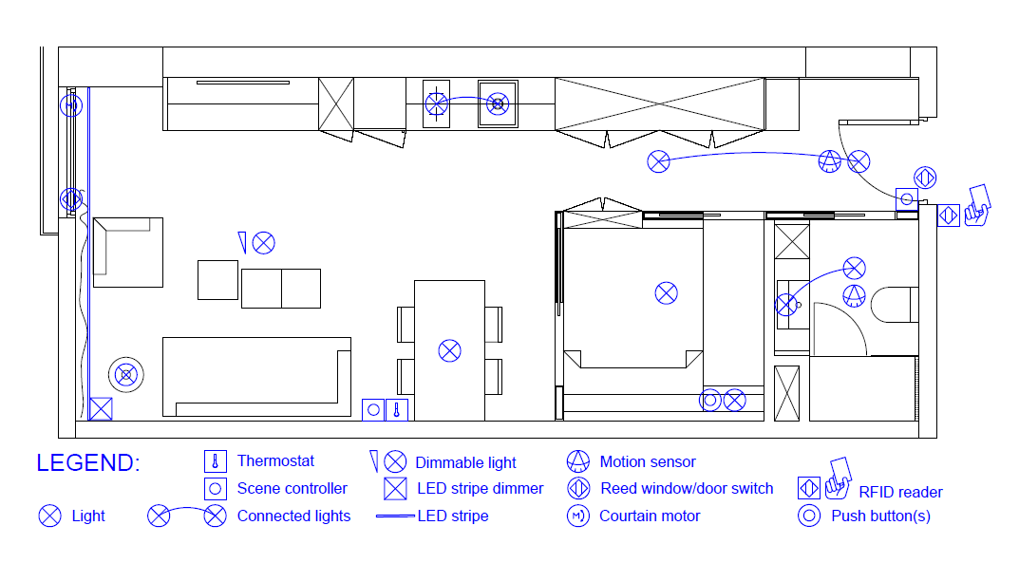

## Appartment

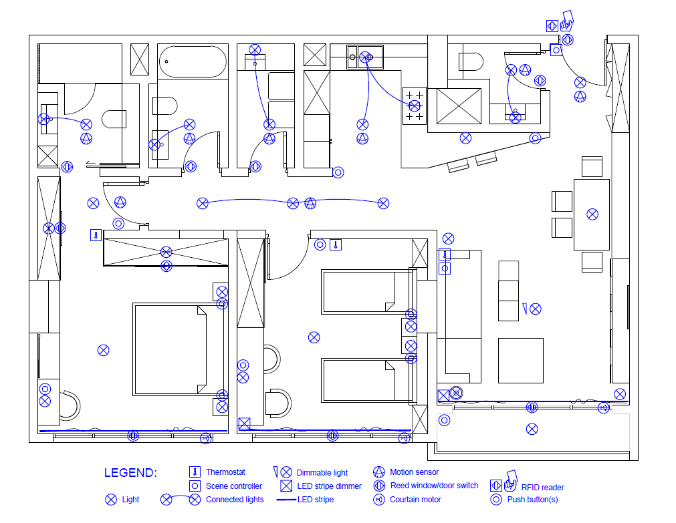

## Appartment 1

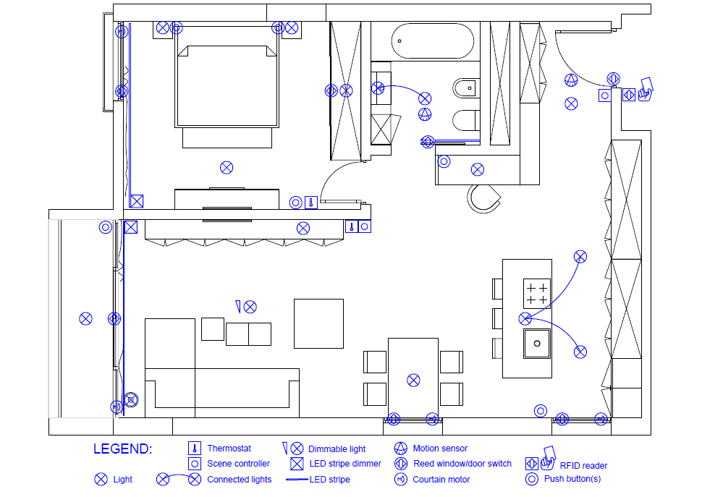

## Appartment 2

