# HIQ Home

Your home will be equipped with the most advanced home automation system. HIQ home is intuitive, easy to use, reliable and ready for future expansion.

### What is new or different?

HIQ home is a native smart home. It is a part of your home and it has been designed for your comfort and safety. All devices are wired and interconnected through intelligent controllers providing you full freedom of functionality, possibility to evolve and change and come combined with fast and reliable operation. You can access and control everything from anywhere. All you need is your smartphone and internet.

### Various types of comfort

LIGHT & SHADE: all lights and blinds (shades, curtains…) are controlled and combined in scenes for easy selection and change. Lights can be dimmed, RGB LED’s are used for mood change, and white temperature control can mimic the sun as its colour changes through the day.

THERMAL: heating and cooling when necessary and combined with ventilation control. Regardless which method is used (AC, radiators, fan coils, active floor or ceiling), HIQ will always ensure best comfort, scheduled operations and intelligent energy saving.

EASY CONTROL: use push buttons or smartphone to trigger immediate action. Scenes are memorized and recalled through touch scene controllers and smartphone. Customized appearance and layouts are available through myHIQ. Use HIQ Configurator to re-configure your home as many times as you want. Subscribe to HIQ Universe to access your home through internet and to enjoy innovative services.

### Safety and Security

INTRUSION: HIQ uses all available sensors to care for you home security and your safety. It knows when you are at home and when you are away. If an abnormal action is detected, HIQ will inform you and your service provider.

GAS, WATER: sensors are connected to detect dangerous gas level, flood or any other hazardous situation. You will be informed and the necessary action will prevent further damage.

FIRE: fast rising of temperature means potential fire hazard. Your HIQ-home will detect it and inform you and your service provider.

AAL: Ambient Assisted Living is gaining importance. Sometimes supporting our daily routine means additional comfort and sometimes, especially when one lives alone, understanding that our daily routine is violated means additional safety.

### Efficiency

ENERGY EFFICIENCY: energy monitoring, advanced artificial intelligence based algorithms, machine learning and connected services can save energy, let you enjoy smart grid benefits and be sustainable. Take informed decisions or let HIQ save for you.

AUTOMATIONS: things just happen. HIQ home uses your smartphone to understand your habits and adapts your home to them. Your home knows when you come and when you leave. It adapts your settings to your schedules and it can trigger actions based on your wake-up time. Your home becomes smarter as it understands you better.

FM: facility management may be a nightmare. That is why HIQ home can help you. It connects you to your FM services provider. Your service provider will know what is wrong. Maintenance will become predictive and less intrusive. Services will be seamlessly and without disturbing you.

### Automations

Things happen automatically and they happen in the way you expect them to happen. Explore and enjoy various automations. You can even add your customized automations, if you want to adventure in the simple if-then-else programming language.

### Connectivity

Everything is connected in the modern world. HIQ Home connects your home to the internet in the secure and controlled way. You can access it from any point of the Earth.

HIQ can be connected to other cloud services, such as Alexa, Watson, Azure and others.

### Expand, upgrade, modify

It is easy to expand and upgrade your HIQ home. You can choose from wired and wireless expansion modules. In case you prefer wired modules, but you do not want to adventure in any construction work, we have developed our NEXT-tape wire, which is simply self-glued to the wall. Use HIQ-Configurator to easily adapt functionality to your existing and future needs.

“HIQ home will importantly improve your comfort, safety & security, efficiency and lifestyle.”

*In HIQ we take great efforts to constantly improve our products and services, which ensure best possible customer experience. Newly developed features are available to all HIQ home users. Please check for new versions periodically and install them at your convenience.*

# Comfort

### LIGHT & SHADE COMFORT

Lights and shades are basic elements of light comfort. They are controlled individually, as a part of a scene, by smartphone or from tablet and computers.

**ON OFF LIGHTS**

HIQ Home can control any type of light. By simple push of button lights will be toggled.

**DIMMABLE LIGHTS**

All dimmable lights can be dimmed thru HIQ home.

**RGBW LED STRIPES**

|  |  |
| --- | --- |
| RGBW (red-green-blue-white) LED stripes are used for interior and/or exterior ambient lighting. Stripes are dimmable and can glow in any colour.  **RGB mode** allows control of hue, saturation and brightness. Desired light colour can be simply picked in myHIQ or HIQ Commander application.  **C:\SkupnaSSD\Za backup\Dokument\Robotina\HIQ\Bivalni kontejnerji\NEST_myHIQ\Images\rgbw_hue.png** | C:\SkupnaSSD\Za backup\Dokument\Robotina\HIQ\Bivalni kontejnerji\NEST HIQ manual\LED_stripe.jpg |

**CONTROLLED SOCKETS**

|  |  |
| --- | --- |
|  | HIQ home controls Sockets for standalone lights. They can be individually controlled and used for floor lamp, table fan, hi-fi system, projector and all kinds of appliances. You can automatically power off dangerous appliances like iron, kettle or cooker when you are away. |

**SHADE CONTROL**

HIQ home controls all types of blinds, shades, curtains and similar motorized equipment. They are controlled individually, as a part of a scene, by smartphone or from tablet and computers.

**ADVANCED LIGHT AND SHADE CONTROL**

HIQ home is the first system, which enables you to control light and shade in the advanced way. You can create scenes, use timetable (scheduler), advanced automatic functions like “ready light” and even mimic colour of the sun through the day. Automations will automatically adapt your home to your lifestyle.

You can always change functionality of your lights and shades, meaning you can **digitally transform** your home.

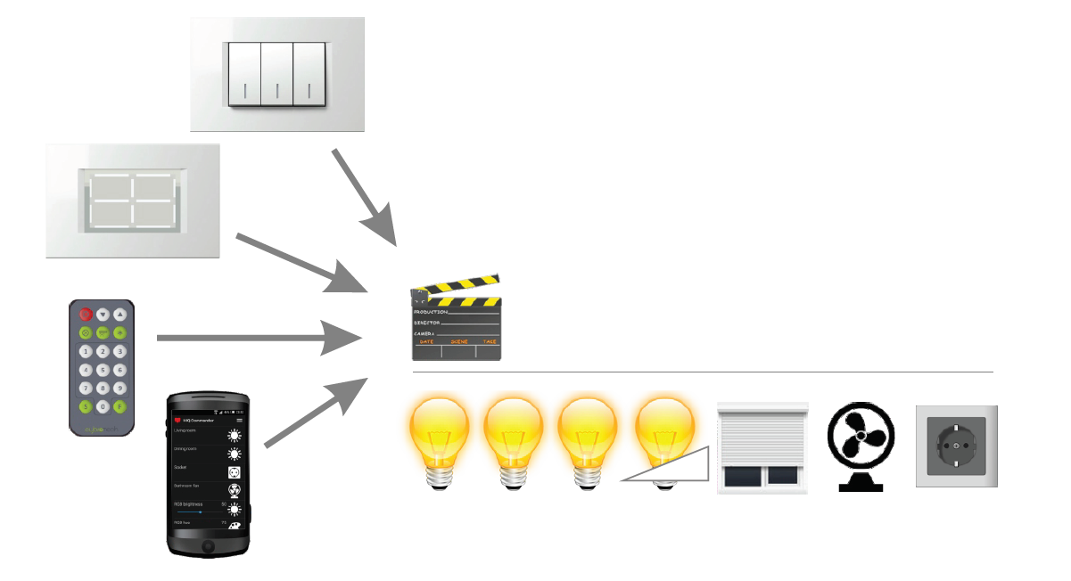

**AUTO OFF/ON:** On delay and off delay (and automatic off) can be configured for every light individually.

**AUTOMATIC LIGHTS:** presence sensors and door sensors are to turn lights on automatically. Same sensors are for intrusion alarm.

**READY LIGHT – perfect, fully automatic light control**

Ready light is an advanced and patented lighting system, based on motion and door sensors combined with intelligent algorithm. It is best suited for closed spaces that residents don’t occupy permanently, like bathrooms, toilets, storage rooms and similar.

When the door begins to open, door sensor is activated and the light automatically turns on. When a person enters the room and closes the door, motion sensor activation means person is surely in the room. As long as the door is closed, light will stay on.

When person leaves a room and closes the door, system will wait for a short time and then turn the light off. If the door is left open, long timeout is active. If the motion sensor is not activated during that time, light switches off.

**EVO LIGHT – light that make you feel well**

Sun is the only light to which our bodies and minds have been used since creation. It is not a surprise that we feel most comfortable and are most efficient if sunlight is available. Main characteristic of sunlight is that its color changes thru the day.

EVO LIGHT Function does the same. It provides synchronization between light colour (temperature of white) and sunlight colour, based on location, date and time of the day ensuring best health, comfort and efficiency.



**AUTOMATIONS – light and shade adapt to your lifestyle**

Your smartphone is your individual “window” to the world and so it is your main personal control for your home. Your phone knows more about your lifestyle than anybody else does. It wakes you up, knows your schedule and stays with you.

HIQ home uses your phone to maximize your comfort. Automations can couple your lights and shades with your smartphone to maximize your comfort and safety. For more, please check the automations section.

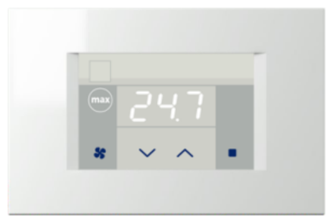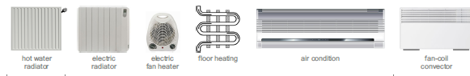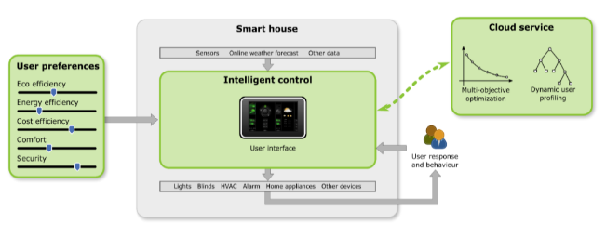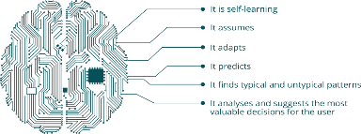

### THERMAL COMFORT

Thermal comfort is a key factor of wellbeing and health and it has major impact on energy consumption. HIQ is designed to guarantee maximum comfort with best efficiency.

HIQ home controls your thermal comfort. It uses intelligent thermostats, which lets you set desired temperature and turn zone on and off. Artificial intelligence is used to achieve best possible comfort and energy efficiency. Timetables (schedule) are provided for comfortable heating/cooling setup. Different heating and cooling elements can be connected to the HIQ home.

HIQ home can automatically detect presence and adapt its behaviour. HIQ home automations dynamically adapt your heating/cooling to your lifestyle. All HIQ home users can subscribe to HIQ universe EE service, an advanced cloud based energy optimization system.

# Safety and Security

HIQ helps you to keep your home safe and secure. It uses all sensors installed for other functionality, like presence sensors, which are normally used for lights, to detect abnormal situations. In addition to this, specific sensors like gas, flood, and fire can be connected.

In case of abnormal situations, HIQ home will send you text messages sound an alarm or alert or even automatically call help.

All HIQ home users can subscribe to HIQ universe S&S service, an advanced cloud based safety and security software, which constantly scan all sensors and detect abnormal situations.

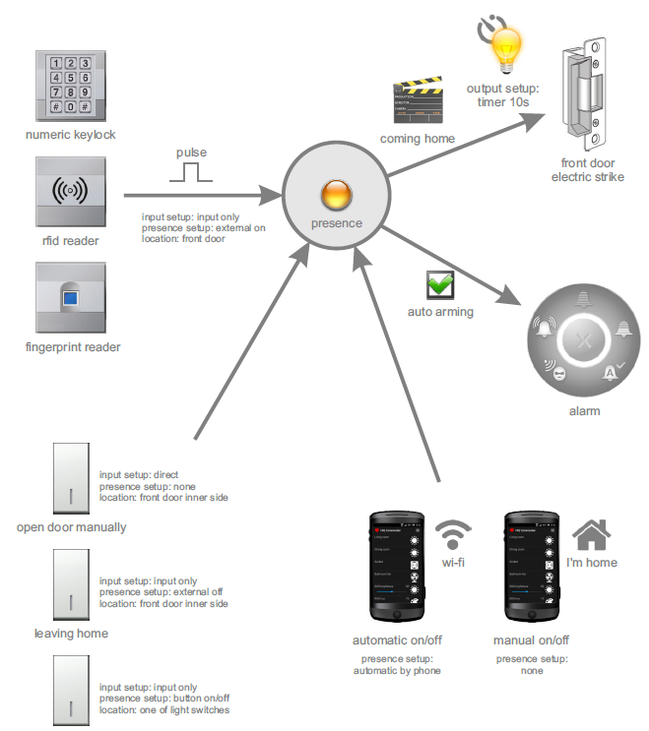

HIQ home safety and security functions are intuitive and simple to use. HIQ home detects your presence and automatically or manually configures itself.

# Access control

You can connect almost any type of access control to HIQ. In addition, HIQ itself offers simple and efficient way to control who and when can enter into your home. You can control electrical locks with your smartphone, RFID tags, fingerprint, combination locks or other identification systems. Same system can be for garage door, where you can also use telephone call or automatic number plate recognition system.

### Smartphone

|  |  |
| --- | --- |
|  | Uniquely identified smartphone offers cost efficient, simple and secure solution - just press a button in your HIQ Commander. You can even remotely unlock the door to let your friends in. |

### Fingerprint reader

|  |  |
| --- | --- |
| C:\SkupnaSSD\Za backup\Dokument\Robotina\HIQ\ekey\ekey_integra.jpg | You don’t have your smartphone always with you? Then use your fingerprints! We can add up to 99 fingerprints and enable different zone access. Can be combined with RFID reader in the same device. |

### RFID tag reader

|  |  |
| --- | --- |
| C:\SkupnaSSD\Za backup\Dokument\Robotina\HIQ\Generalni_opis_za_kupce\rfid_reader.jpg  C:\SkupnaSSD\Za backup\Dokument\Robotina\HIQ\Generalni_opis_za_kupce\rfid_reader_key.jpg | RFID (Radio-frequency identification). Functions are similar to fingerprint reader, but the user has to carry an identification badge or a card. |

### GSM Controlled

Open your front door with a simple call from a predefined telephone number(s).

# Control and operation

HIQ home is easy to use. It is also simple to install and it allows you to digitally transform your home. You can change functionality of your home through your lifetime using intuitive, graphical configuration software.

### DAILY OPERATION

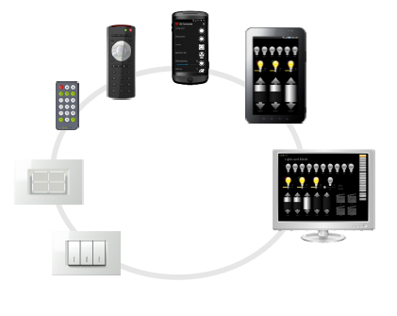

HIQ home offers manual or automatic control - user can manually override output at any time.

### PUSH BUTTONS

Use normal pushbuttons to operate lights and shades. Pressing and releasing a pushbutton toggles the state of light or moves shade. Advanced use of push buttons is available with dimmers, RGB(W) and shades. They can be configured to set desired scene with a single press.

### SCENE CONTROLLERS

Pushbutton with LED or touch scene controllers are used to memorize and recall scenes.

|  |  |
| --- | --- |
|  | Scene controller can control up to 4 freely programmable scenes. Scenes include lights, RGBW, dimmers, blinds and sockets. It is a great solution for triggering even complex scenes quickly and easily without using smartphone or a tablet. It can be used by anyone including kids, elderly and guests who may not have full access to your HIQ applications. You can select, save and recall any combination at any time.  **Saving the scene:**   1. Set lights, dimmers, sockets and blinds to desired position with pushbuttons, service switches, myHIQ, HIQ Configurator or HIQ Commander. 2. Use long press or touch (until the beep sounds) to save the scene.   **Recall the scene:**   1. Press scene button or touch scene zone |

### THERMOSTATS

Thermostats are used to set and visualize the room temperature and operate your HVAC (Heating, Ventilation and Air Conditioning) system. Several thermostats can be connected to achieve optimal comfort in every room. Temperatures can be controlled or just monitored (like outside temperature, domestic hot water temperature...).

|  |  |
| --- | --- |
| C:\SkupnaSSD\Za backup\Dokument\Robotina\HIQ\Bivalni kontejnerji\th-1t-iq.png | Use up and down to set desired temperature and other touch zones to temporally turn zones on and off.  Thermostats come in different design, but all offer comfort and energy efficiency. |

### IR REMOTE

|  |  |
| --- | --- |
| C:\SkupnaSSD\Za backup\Dokument\Robotina\HIQ\Bivalni kontejnerji\NEST HIQ manual\IR.png | One can use any IR remote that transmits Philips RC-5 codes. Remote controllers are configured with HIQ Configurator. IR receivers are located in scene controllers and in thermostats. |

### HIQ Commander

|  |  |
| --- | --- |
|  | HIQ Commander is a smartphone application (iOS / Android) and can be downloaded from App Store/Google play. It allows the user to control lights, sockets, blinds, heating/cooling and alarm.  When started for the first time, the application automatically detects connected devices. The following devices are supported:   * lights (controlled sockets...) (on/off) * RGBW dimmers (0..100%, hue, saturation) * blinds (up/down, move to position) * scenes (apply, inverse, memorize) * thermostat (set-point, temperature, fan speed)   For each device, the user can give a recognizable name and select an appropriate icon. |

You can also control various devices, such as bathroom fans, table fans, electric heaters or audio/video systems, which are connected to controlled socket. RGB dimmer includes a white temperature mode, which allows user to select between cold daylight and warm evening light. Thermostat allows temperature control.

HIQ Commander can work using a local network or internet if you create an account on the HIQ Universe.

### HIQmyHome

HIQmyHome is customized to best suit every individual ambient and every user. It is the most comfortable and personal way to interact with your home.

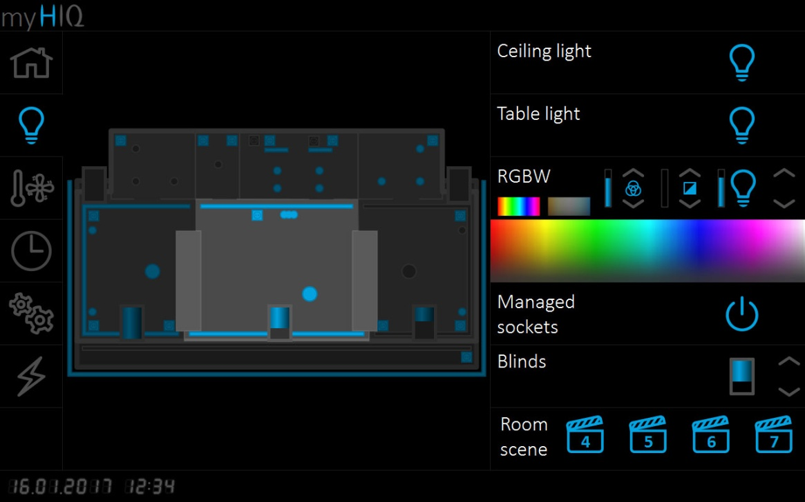

### REMOTE (OUTSIDE HOME) CONTROL

Your smartphone can control your home when it is logged in your home WiFi network or through internet.

With smartphones and HIQ Commander your home can be controlled through internet. HIQ Universe Cloud service is available for secure access from any place. Operation is same as it is from your home.

|  |  |
| --- | --- |
| C:\SkupnaSSD\Za backup\Dokument\Robotina\HIQ\Bivalni kontejnerji\NEST HIQ manual\hiq_universe_00.png | HIQ Universe is a cloud solution which enables remote access and management of your HIQ home.  Access your account on <http://my.hiq-home.com>. On “Phones” page you can manage your smartphones and enable/disable new phones.  Various subscription-based services are available and new ones are constantly developed and offered by various providers. Use your HIQ Universe account to connect to third party, cloud based services like Azure, Watson, Alexa and others. |

# 

# Advanced functionality – home becomes smart

### **SUBSCRIPTION SERVICES**

Benefits of modern, connected society and Internet of things (IoT) can be enjoyed by subscribing to external services.

Various subscription-based services are available and new ones are constantly developed and offered by different providers. Use your HIQ Universe account and Home linker to connect to third party, cloud based services like Alexa, Azure, Watson and others.

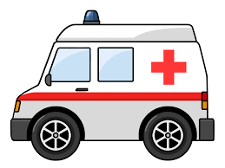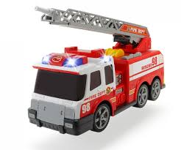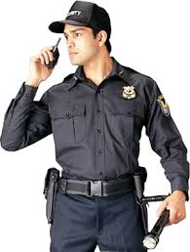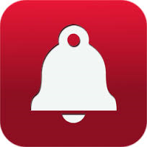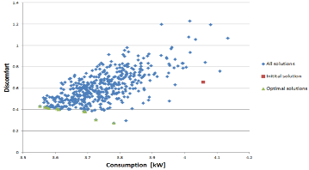

### **AUTOMATIONS**

**Automations are part of every HIQ home and do not require any subscription. You need to configure them (use HIQ Configurator) and enjoy.**

Automations combine HIQ home and your smartphone (HIQ Commander app). They execute tasks automatically and are triggered from Home controller or smartphone. They use sensors (like presence and door), smartphone information and other information to optimize user experience. Automations can be basic or very advanced and may include artificial intelligence functionality.

#### Automations

|  |  |  |  |
| --- | --- | --- | --- |
|  | **Coming home**  Let your house show how happy it is when you come back home. When phone connects to your network, lights and heating or cooling will turn on automatically. |  | **Default set point**  When active, any set point adjustment is valid for one hour, then it returns to the temperature defined in automation setup. |
|  | **Leaving home**  When you leave the house, smartphone disconnects from home wi-fi network, a few minutes later system will turn lights and heating/cooling off. |  | **Bio offset**  Following your natural biological rhythm (chorotype), let the house be a little warmer (or cooler) at the specified time of the day. |
|  | **Smart lights**  In the evening hours, when sunlight goes down, automatically set evening scene, turn on the lights and lower blinds. Works only when tenants are at home. |  | **Connect charger**  Do you charge your phone every day before going to bed? Use that action to automatically turn lights and heating/cooling off. |
|  | **Random lights**  When nobody is at home, discourage snooping with a simple deception: turn lights on and off to leave impression that house is not empty. |  | **Disconnect charger**  You disconnect your charger in the morning, right? Use that action to automatically turn lights and heating/cooling on. |
|  | **Comfort wake up**  System will turn thermostat on a predefined number of minutes before smartphone rings, whenever you set the alarm. |  | **Call notification**  When you receive a call, selected light will turn on and off a couple of times, to bring the attention when phone is away or silenced. |
|  | **Sunny wake up**  Wake up naturally, by gradually lifting blinds and let the sunlight wake you up, a predefined number of minutes before smartphone alarm. |  | **Text notification**  When you receive a text message, selected light will turn on and off a couple of times, to bring the attention when phone away or silenced. |

#### Timetable

Timetables (scheduler) define periods in which the heating/cooling system is active, when ventilation and/or scene is active. Timetables are independent, and may be used to handle separate zones, e.g. living or sleeping area. Manual override is possible at any time; timetable will catch on with the next transition.

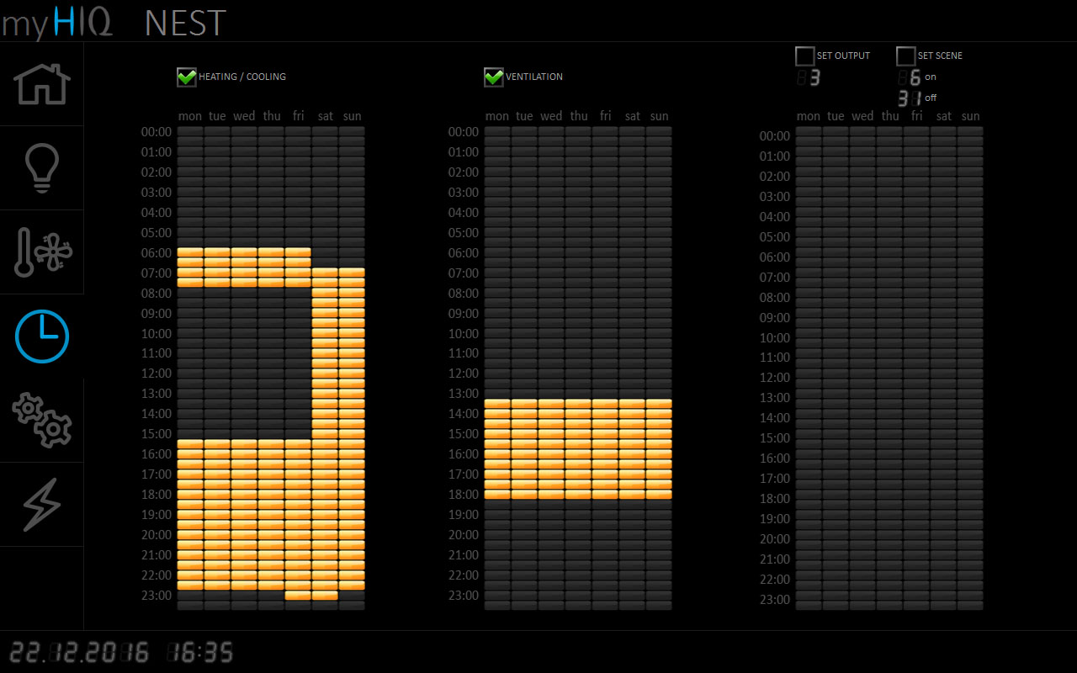

Timetables are used also to set scenes, turn on/off lights and other devices.

Energy

Energy monitoring is the first step to efficient energy usage. Once knowing how much energy something is using, one can decide and implement a rational strategy for saving.

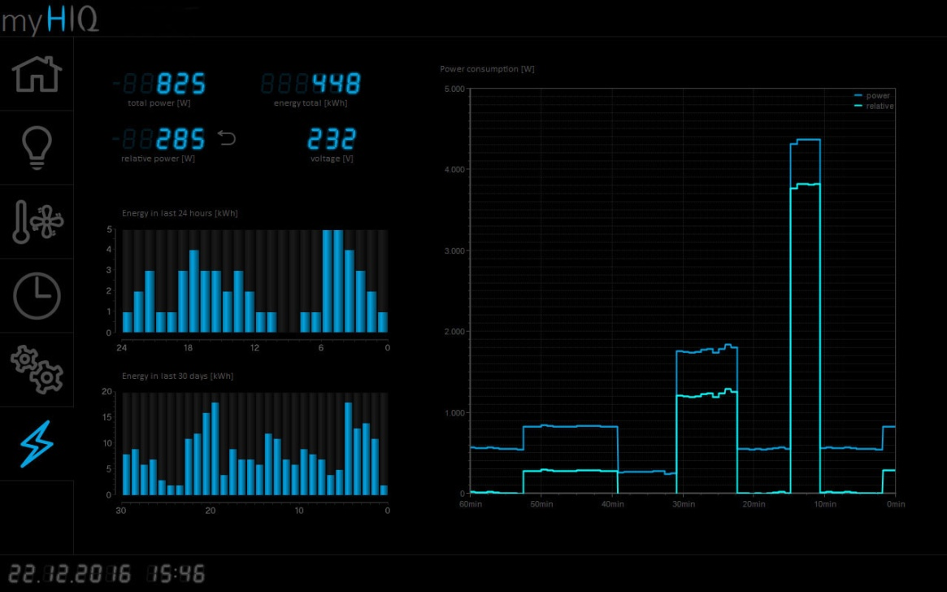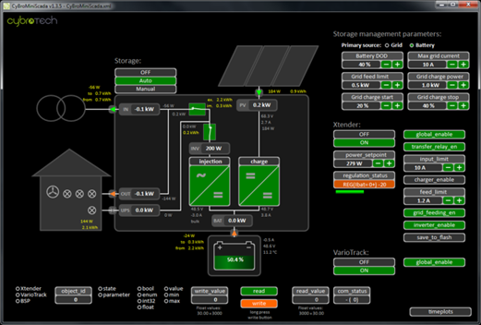

Solar power plants and energy storage can be integrated to provide additional benefits including energy autonomy and substantial savings. You can live a sustainable, green lifestyle.

#### C:\SkupnaSSD\Za backup\Dokument\Robotina\HIQ\Bivalni kontejnerji\NEST_myHIQ\Images\alarm armed.pngAlarm

Alarm system, which is integrated in HIQ Home, uses the same sensors which are used for lighting and automations control. It is automatically activated and deactivated when one of the selected smart phones/tablet connects/ leaves the home Wi-Fi network. Manual activation/deactivation is possible on a smart phone/tablet by toggling alarm icon. Any pushbutton can be configured as alarm on/off.

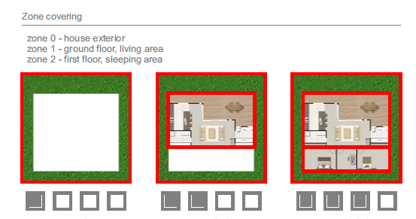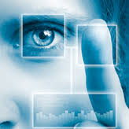

# Modify, expand and customize HIQ home

### HIQ Configurator

Use HIQ configurator to digitally modify (transform) your home. You can change almost every functionality without changing installations.

|  |  |
| --- | --- |
| C:\SkupnaSSD\Za backup\Dokument\Robotina\HIQ\Wiki\configurator_screenshot\lights_blinds.png | HIQ Configurator offers easy and fast configuration of the whole system, control of all functions and several graphs, like temperatures and energy consumption. You do not need a specialist to re-configure your home. |

### Video intercom

|  |  |
| --- | --- |
| C:\SkupnaSSD\Za backup\Dokument\Robotina\HIQ\Generalni_opis_za_kupce\Vario1a.jpg | A wide range of video intercoms can be connected to HIQ home. Entry-level model work as a stand-alone solution in a local network.  Use premium models for remote interaction with your smartphone, even if you are not at home. A snapshot of your visitors can be send to your email. RFID or fingerprint reader can be combined in the same device. |

* Unique

HIQ Unique is a service offered by HIQ partners, which offers full customization in appearance, materials, user interfaces and can even print your personalized logos on all visible elements. HIQ partners can change functionality, connect various devices and help you to enjoy an unprecedented unique user experience.